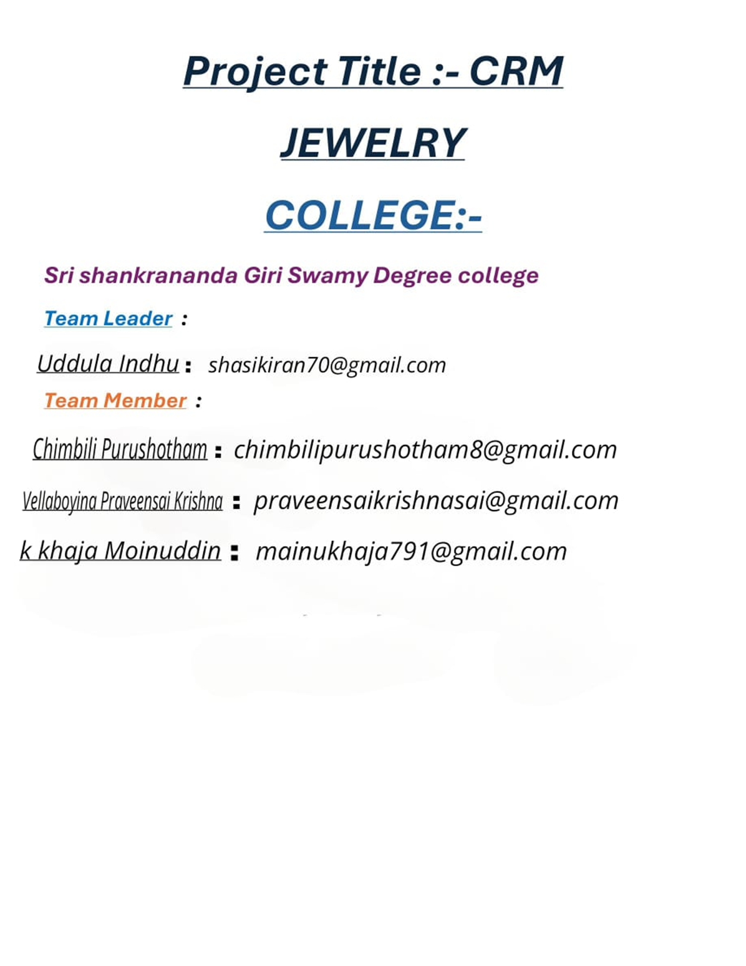

***(1) Project Overview:-***

***A “CRM Jewelry Management project”* aims to achieve several key objectives that ultimately contribute to the growth and efficiency of a jewelry business.**

**The system specifically designed for jewelry business, allowing them To effectively track customer interactions, manage sales leads, and personalize marketing efforts optimize customer relationship and boost sales within the jewelry industry.**

* + **Capture detailed customer information including demographics, purchase history, preferred jewelry types, special occasions, and contact details**
  + **Store and update customer data in real time to maintain accuracy**

***the purpose of a CRM (Customer Relationship Management) system is to help businesses manage and improve their interactions with customers and potential customers. This overarching goal breaks down into several key objectives.***

**CRM, or Customer Relationship Management, is a multifaceted concept that's essential for modern businesses. It's not just a piece of software it's a strategic approach to how a company interacts with its customers.**

**The relationship between CRM (Customer Relationship Management) and CLV (Customer Lifetime Value) is very strong. CRM systems provide the tools and data necessary to effectively calculate, track, and ultimately increase CLV.**

# (2) Objectives : -

**Business Goals :**

**The primary objectives of a Customer Relationship Management (CRM) system are to enhance customer satisfaction, increase sales, improve customer retention, and build strong customer loyalty by effectively managing customer interactions and data across all touchpoints, ultimately achieving business goals like increased revenue, market share, and profitability.**

**CRM (Customer Relationship Management) systems serve a variety of business goals, all designed to improve customer interactions and drive growth.**

**The four main objectives of a CRM**

* **Increase customer retention.**
* **Shorten the sales cycle.**
* **Increase sales.**
* **Decrease customer acquisition.**

**Specific out comes :-**

**A CRM implementation for a jewelry business aims to drive tangible**

**results through enhanced customer engagement and operational efficiency. there are unique considerations that will influence the specific outcomes and key deliveries.**

**(3)** **Salesforce Key Features and Concepts Utilized:-**

**Salesforce is a cloud-based CRM platform that**

**provides various features and concepts to help businesses manage customer relationships, sales, and operations. Here are some key features and concepts utilized in Salesforce**

* **Key features of Salesforce CRM include:**

**contact management, lead management, opportunity management, sales forecasting, reporting and dashboards, automation through workflows, collaboration tools, cloud-based access, mobile accessibility, AI integration, campaign management, and a single source of truth for customer data, allowing businesses to track and manage customer interactions across all channels effectively; with core concepts like lead qualification, opportunity stages, and customer lifecycle management central to the platform.**

★ **We used the following *Objects :-***

* + **Jewel Customer**
  + **Items**
  + **Billing**
  + **Prices**
  + **Customer order**

★ We used ***Tabs*** such as

* Jewel Customer Tab ❖ Item Tab .. Etc.

##  We Created a Lightning App : - Jewellery Inventory System

➢ ***We Created Fields such as :-***

♦ ***Lookup Relationship***

♦ ***Master-Detailed Relationship***

♦ ***Text, Phone, Email Fields in Jewel Customer Object***

♦ ***Number Picklist Fields in Item Object***

♦ ***Currency Fields in Price Object***

♦ ***Formula Field (cross object)in Item Object***

♦ ***Also Created some other Fields.***

★ ***Schema Builder:-***

***The schema builder is a simple graphical interface for visualizing and editing the data model of your Org. The schema builder can get all fields from an Object, perform basic impact analysis of changes to an Object, and show all dependencies on an Object.***

→ ***We Entered object as :-***

* ***Jewel Customer***
* ***Items***
* ***Customer order***
* ***Prices***
* ***Billing in Schema Builders***

### Field Dependencies:-

***Field dependency can refer to a cognitive style, a relationship between fields in a dialog, or a dependency injection technique.*** **Field Dependencies are used to create relationships between fields within an object. They allow you to control the visibility and availability of fields based on the values selected in other fields.**

**We created New Field Dependencies, controlling as “Priority”& Depending Field as ”Expecting Days of Return”.**

###  Validation Rules :-

***A validation rule is one way to restrict input in a table field or a control on a form. Validation text lets you provide a message to help users who input data that is not valid.***

**Created the validation rule for Postal Code field in Jewel Customer object.**

★ ***Profiles:***

**We Created 2 Profiles:**

* **Gold Smith profile**
* **Worker profile**

### Roles:-

**Salesforce roles are record-level access controls that define what data a user can see in Salesforce. roles can be used to determine the visibility access of the user and the data they can access in your Salesforce CRM organization.**

**Added Goldsmith role in CEO Role & Added Worker Role which reports to Goldsmith.**

# *Users: -*

**A user in Salesforce is anyone who logs in to the platform, including employees, customers, partners, and automated users.**

* **Niklaus Mikaelson in Goldsmith Profile**
* **Kol Mikaelson in Worker Profile**
* **2 more Users in Worker Profile**

## Page Layouts: -

***Page layouts control the layout and organization of buttons, fields, s-controls, Visualforce, custom links, and related lists on object record pages. They also help determine which fields are visible, read only, and required. Use page layouts to customize the content of record pages for your users.***

**Created 2 Page layouts in Item object named as: -** ❖  **“Page Layout for Gold”**

❖  **“Page layout for Silver”**

## Record Type: -

***Record Types are a way of grouping many records of one type for that object. These can be applied to any standard or custom object, and allow you to have a different page layout, fields, required fields, and picklist values.***

**Created Record Types in Item Object labeled as Gold & Silver.**

## Permission sets: -

***A permission set is a collection of settings and permissions that give users access to various tools and functions. Permission sets extend users' function.***

**We Created New Permission Sets & Labeled it as “Per to Worker “ And in Item Object we enabled Gold & Silver object permission we selected “Read, Edit & Create “. We added Assignments which we used under Worker Profile users.**

##  User Adoption: -

**User adoption, or onboarding, is the process of customers or new users getting used to a product or service and then deciding to keep using it because it makes a task or goal.**

***In Jewlery Inventory System we created Jewel Customers under Jewel Customer tab. We created some Records under “Item, Prices, Customer orders & Billing”.***

## Reports: -

**Reports give you access to your Salesforce data. You can examine your Salesforce data in almost infinite combinations, display it in easy-to-understand formats, and share the resulting insights with others. Before building, reading, and sharing reports, review these reporting basics.**

**We created 3 reports:**

* **Prices Report**
* **Billings with item and Customer order Report.**
* **Item with Billings Report**

* ***Dashboards:***

**We created dashboards under “Item with Billings Report “, “Billings with item and Customer order Report”, “Prices Report”.**

* ***Flows:***

**Flow is a powerful tool that allows you to automate business processes, collect and update data, and guide users through a series of screens**

**We selected Record Triggered flow and “Selected *the***

***Object as a “Billing” in the Drop-down list. Selected the Trigger Flow where as “A record is Created or Updated”. Selected the Optimize the flow for: “Actions and Related Records” .***

***(4) Detailed steps to Solution Design: -* We created objects:**

♦Jewel customer

♦Item

♦Billings

♦Prices

♦Customer Order

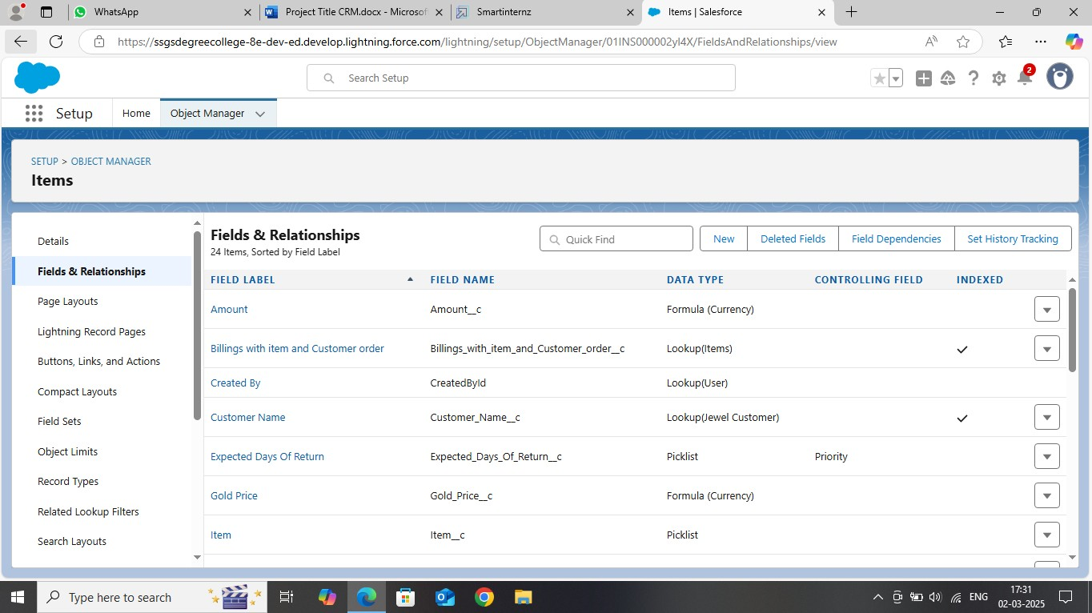

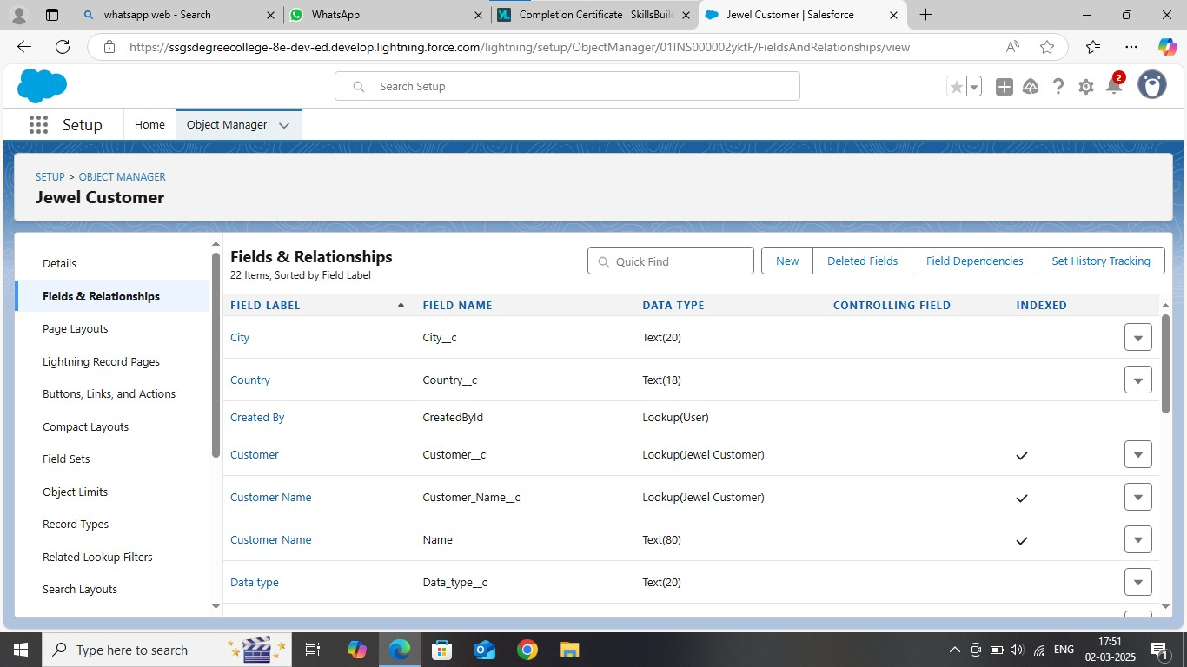

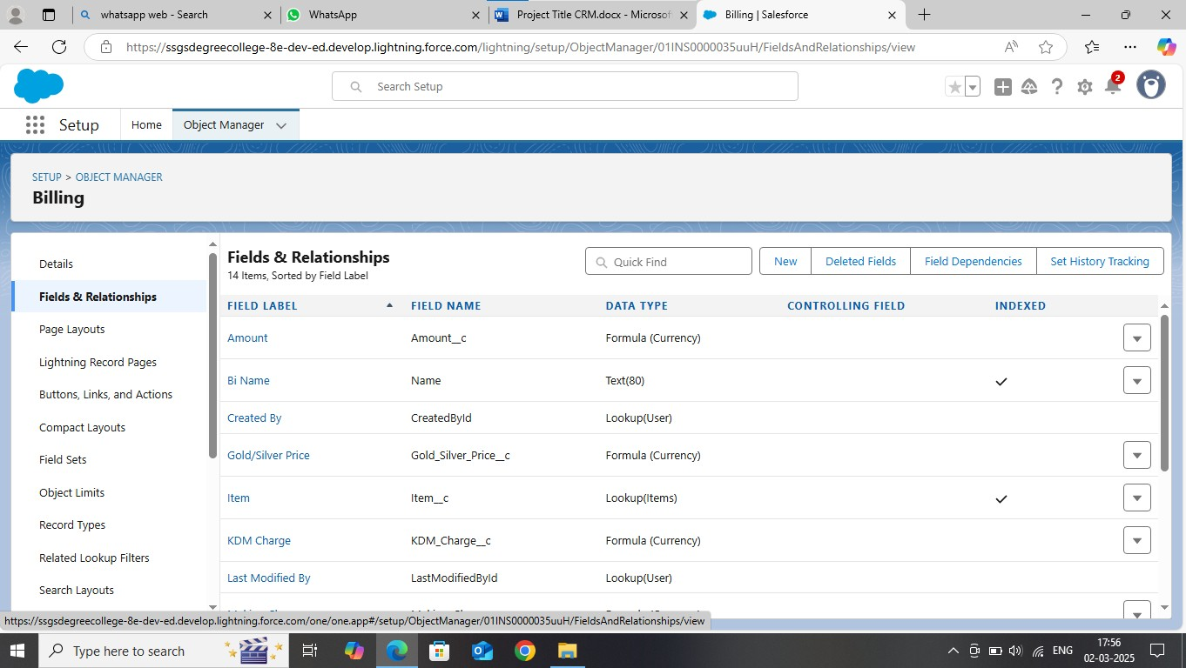 ***We used to 2 Profiles: -***

* *Gold Smith Profile*
* *Worker profile*

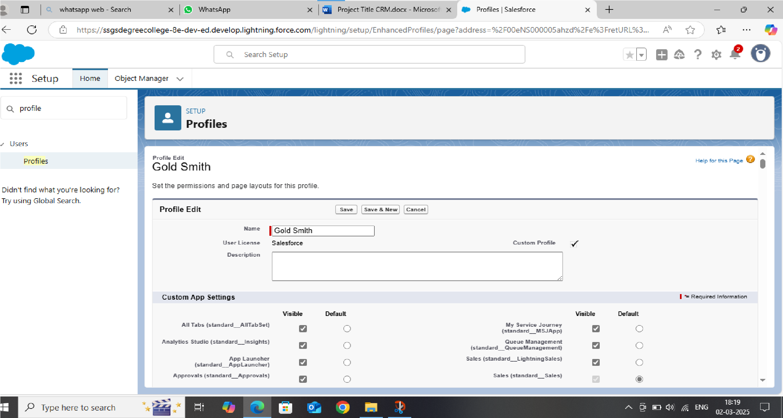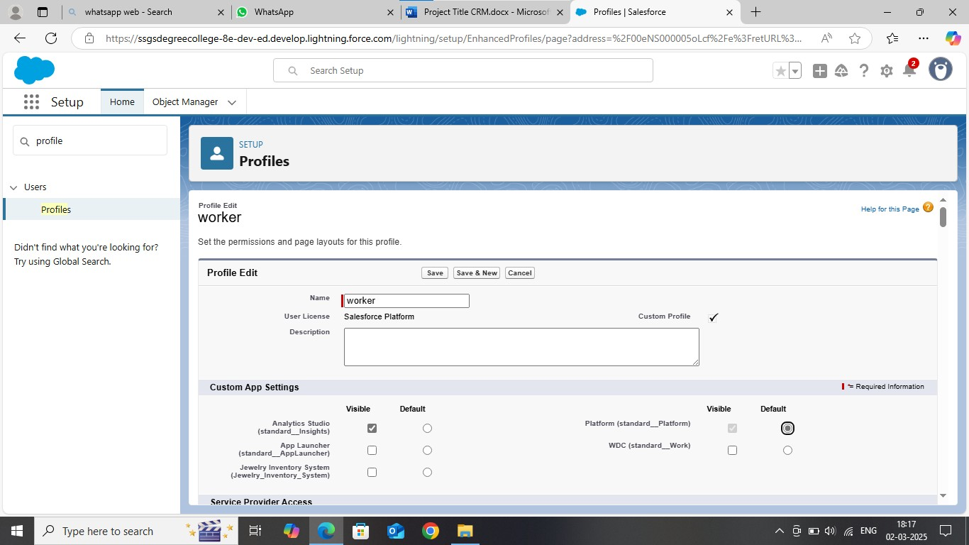

## Lighting App: -

### Roles: -

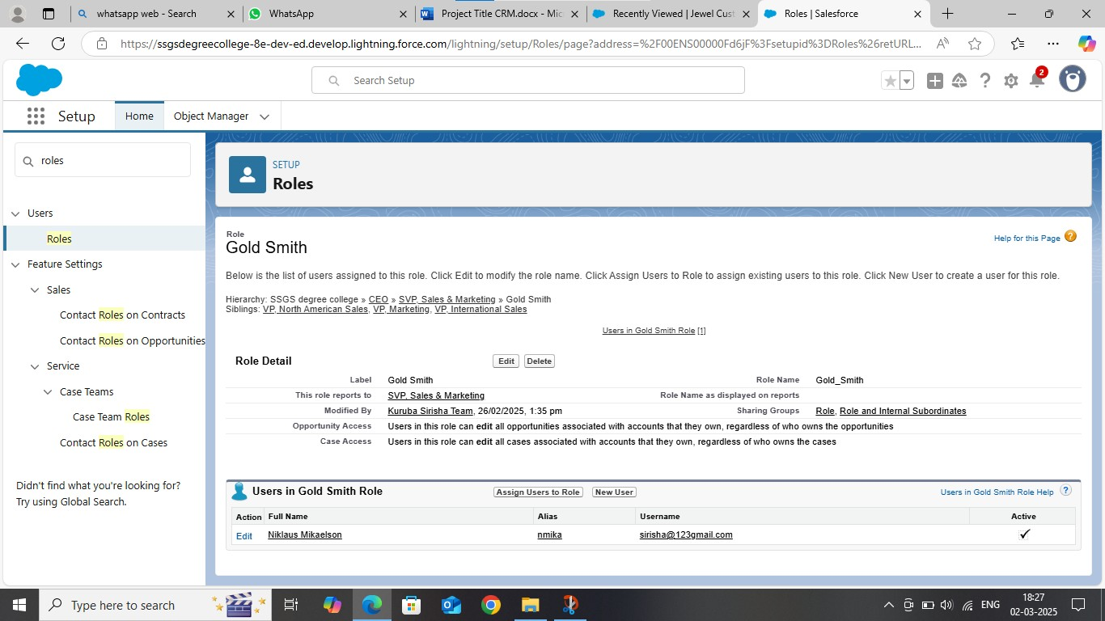

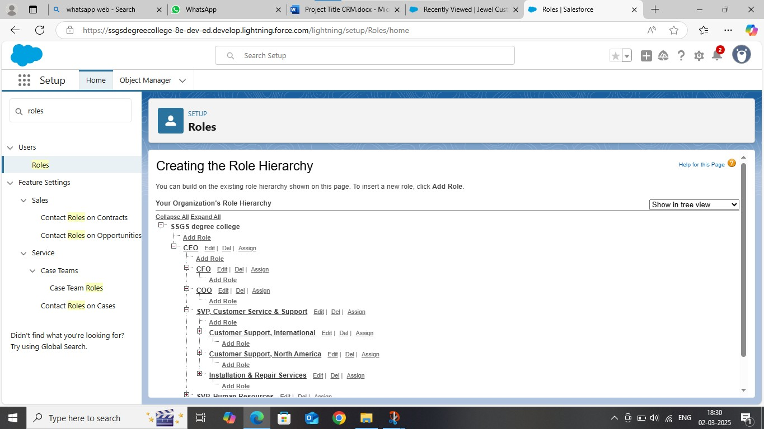

**Users: -**

* *Niklaus Mikaelson*
* *Kol Mikaelson*

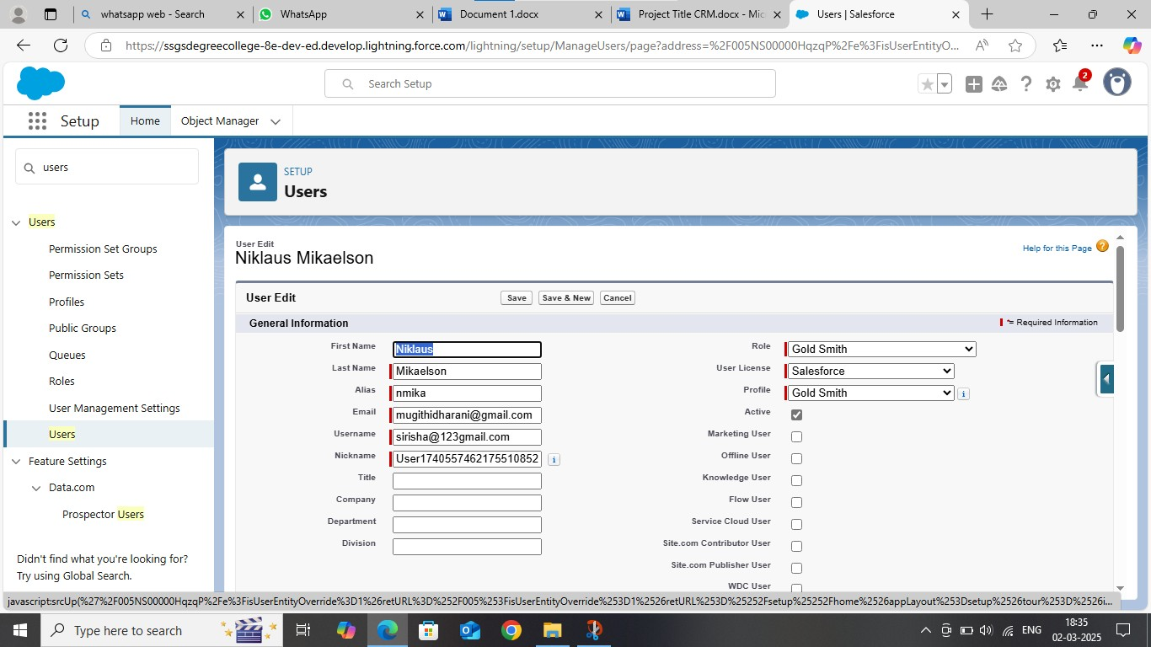

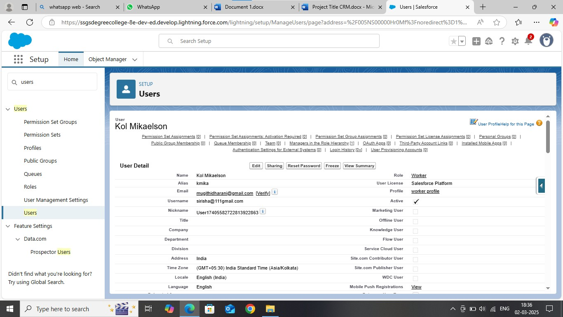

**We created 2-page layouts:**

**Page Layouts for Gold & Silver**

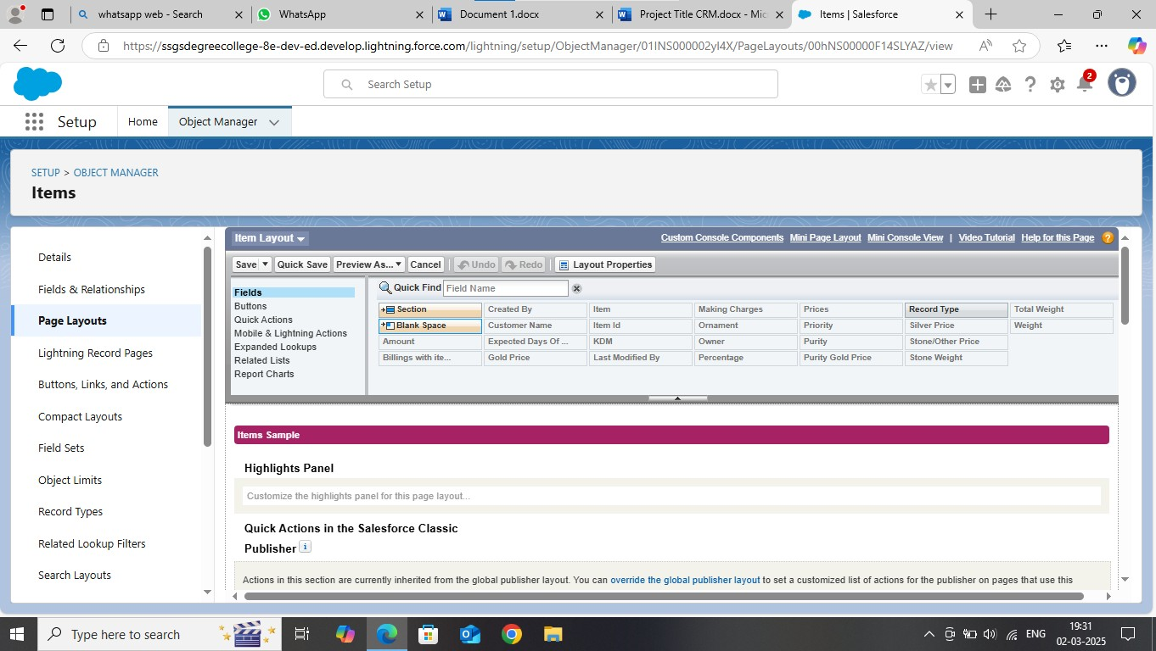

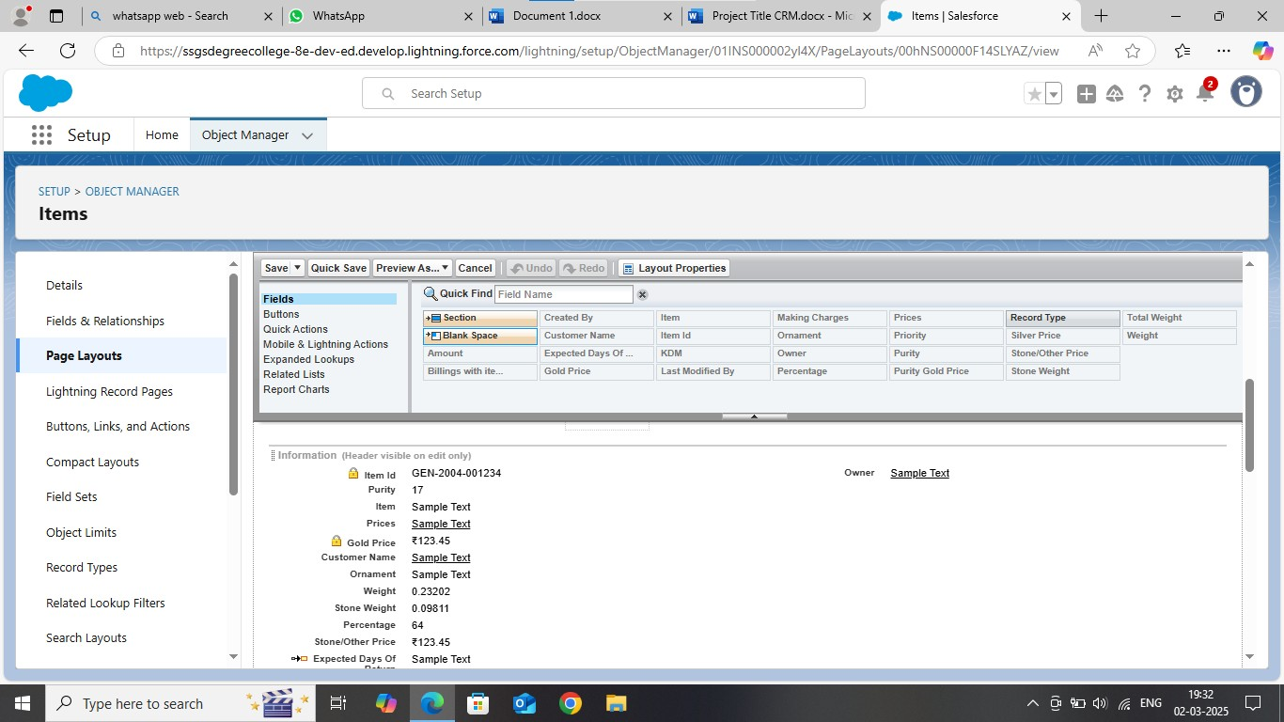

**We created 3 Reports:**

♦ ***Prices Report***

♦ ***Item with Billings Report***

♦ ***Billing with Items & Customer order***

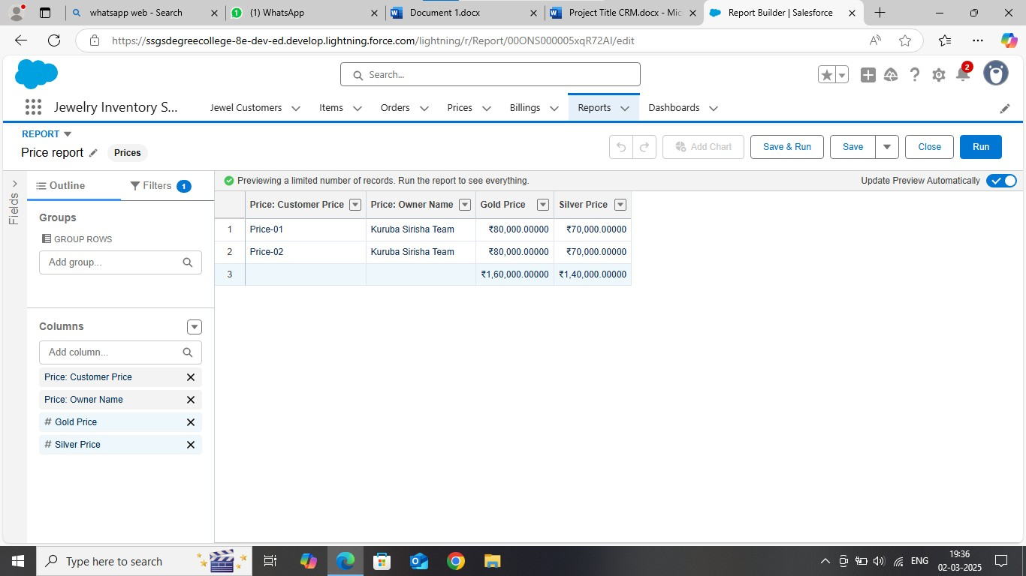

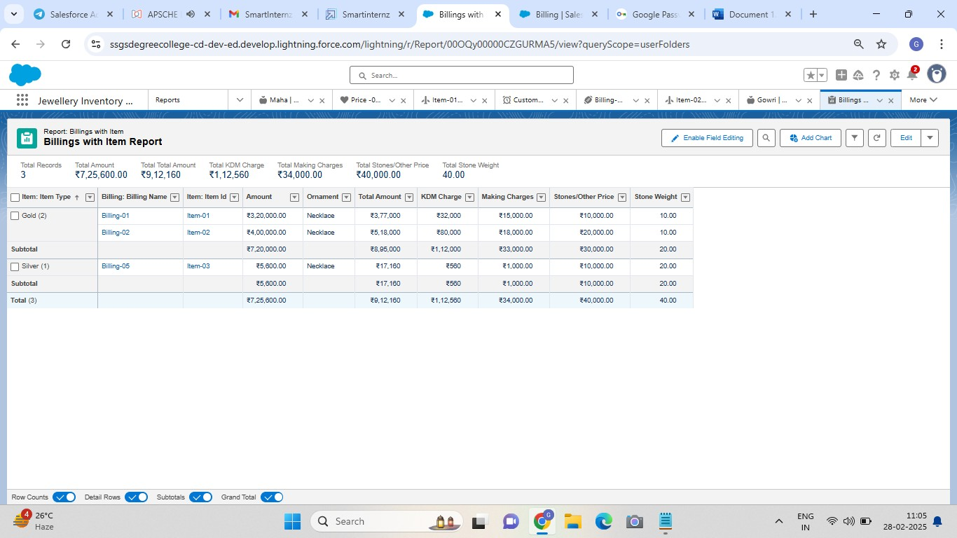

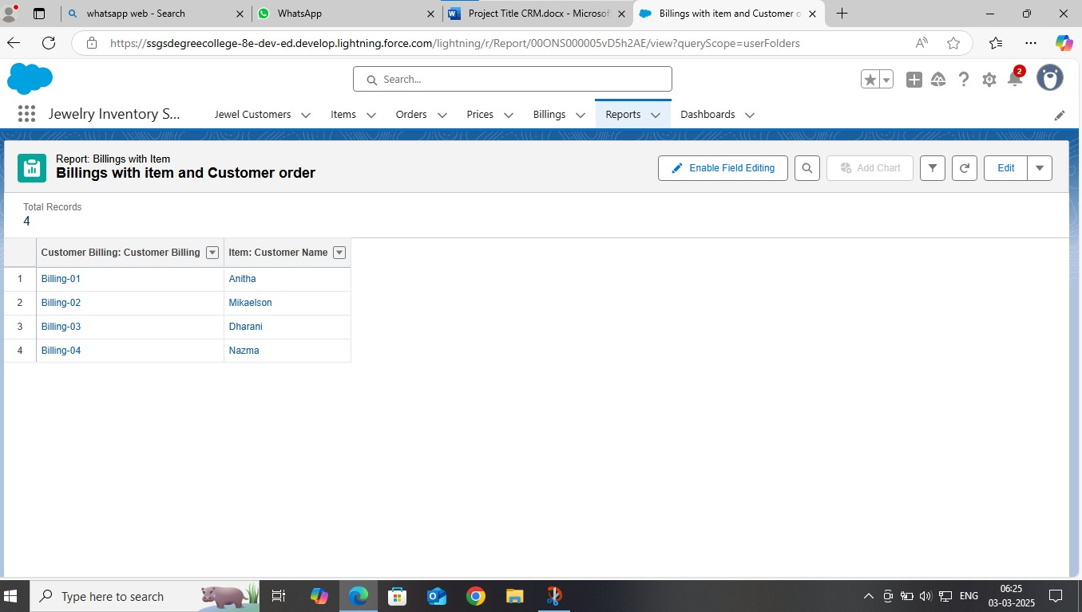

#### Dashboard: -

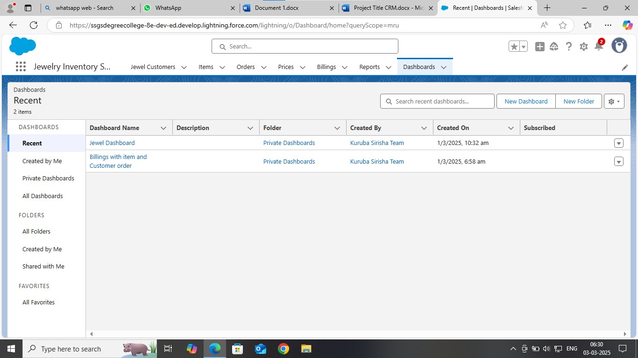

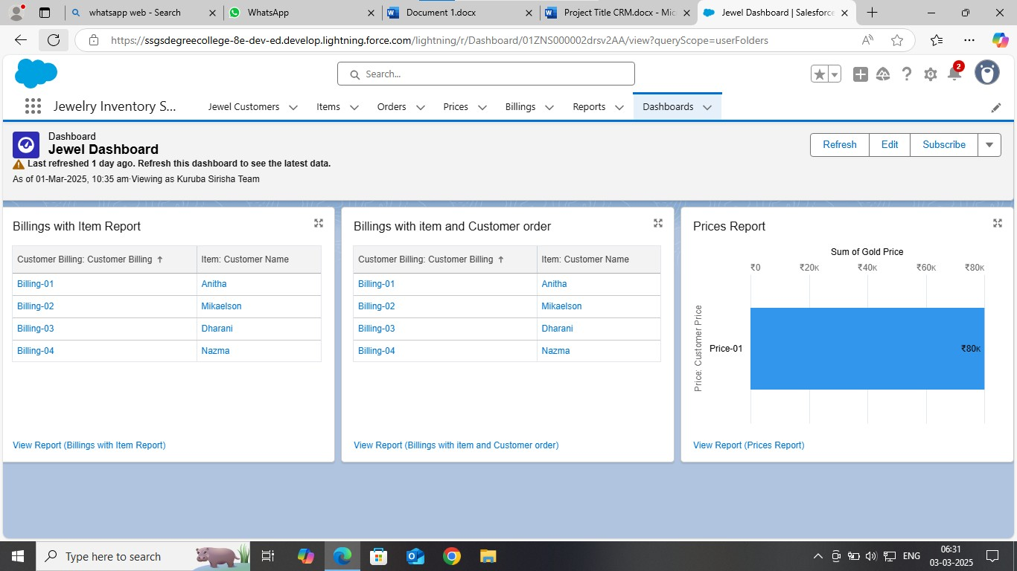

#### Validation Rules: -

**Created Validation Rules under Jewel Customer & Item**

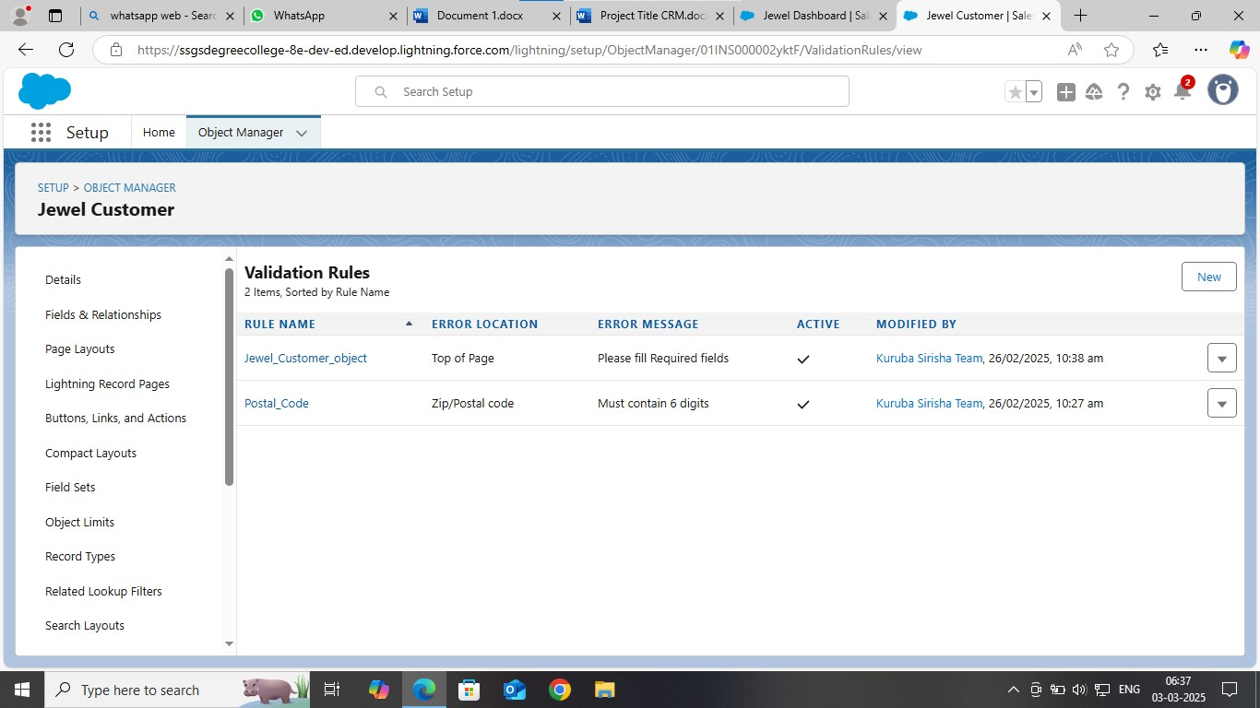

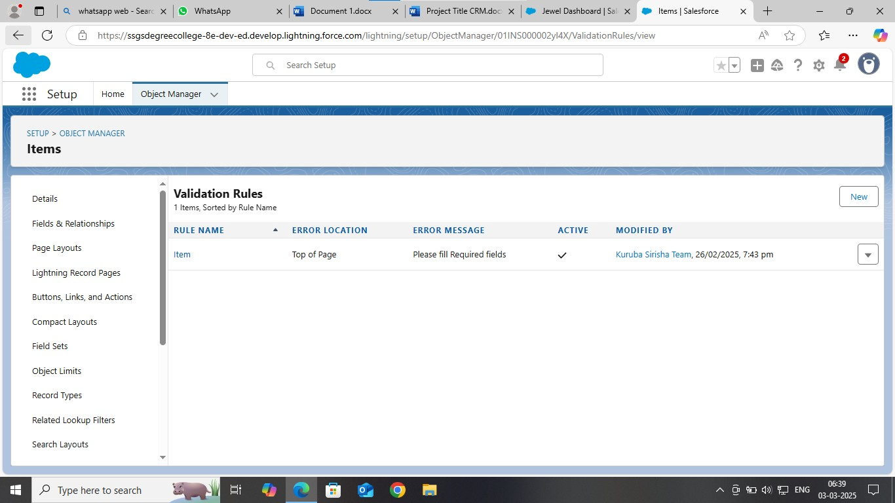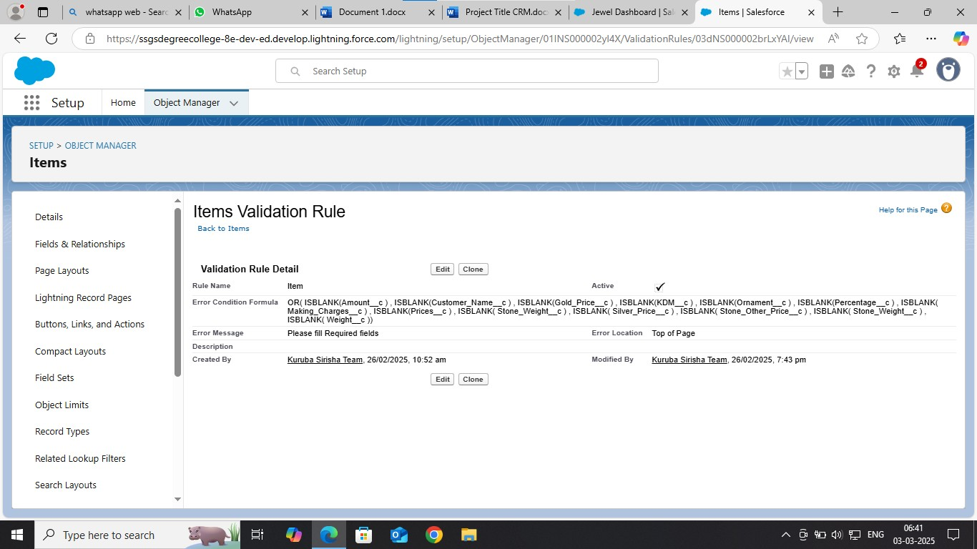

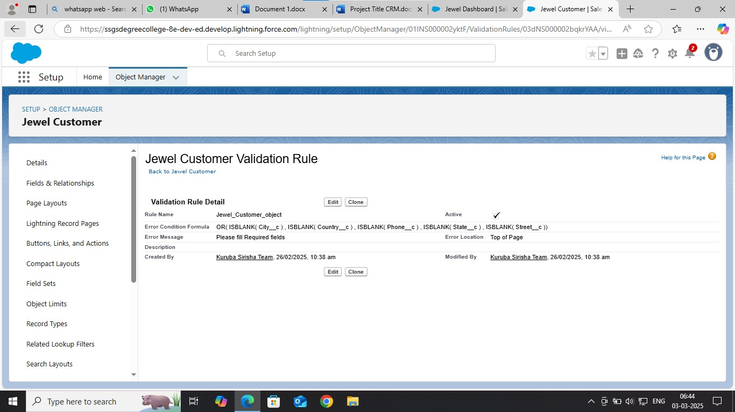

#### Schema Builder: -

**We created Schema Builders for Jewel Customer, Price, Item, Customer order & Billing.**

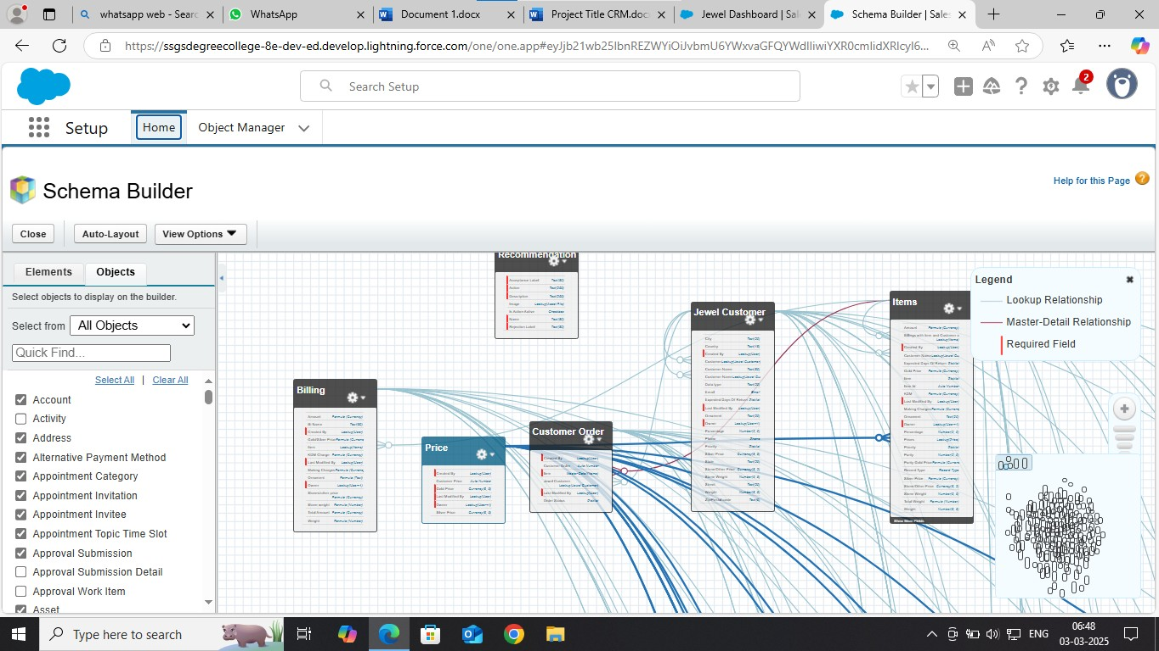

#### Field Dependencies: -

***We created Field Dependencies under Item objects***

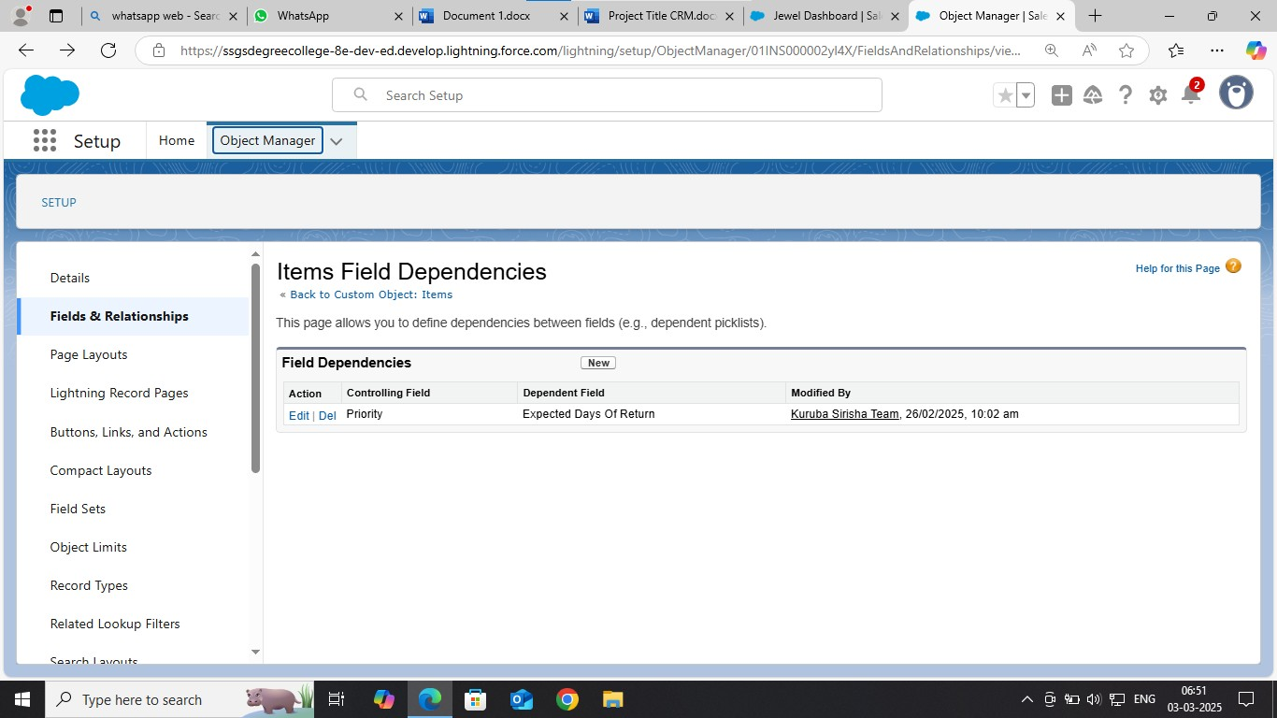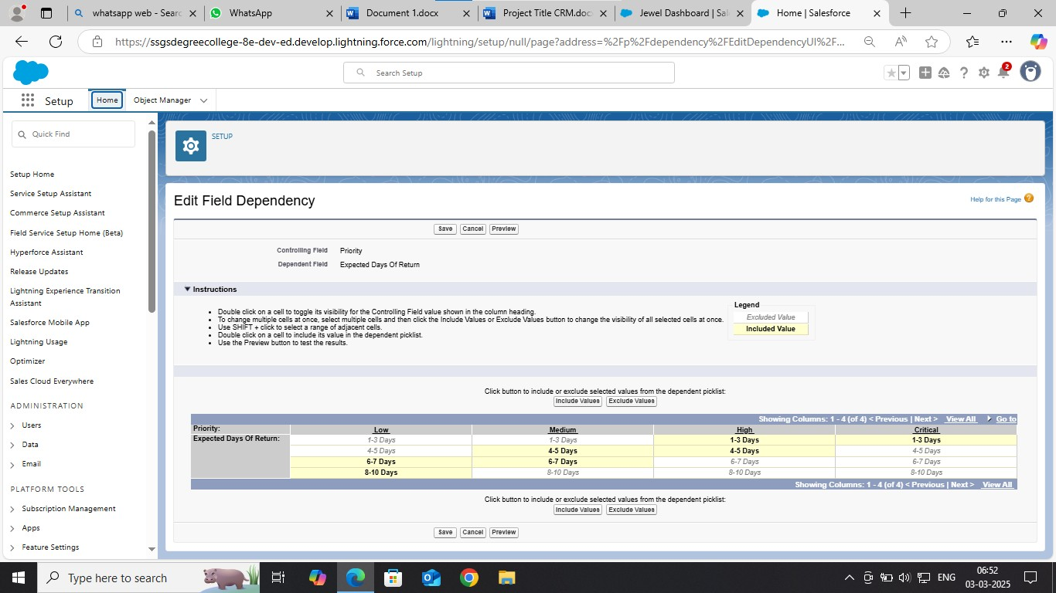

### Tabs: -

***We created Tabs for Jewel Customer, Prices, Items, Billing & Customer Order.***

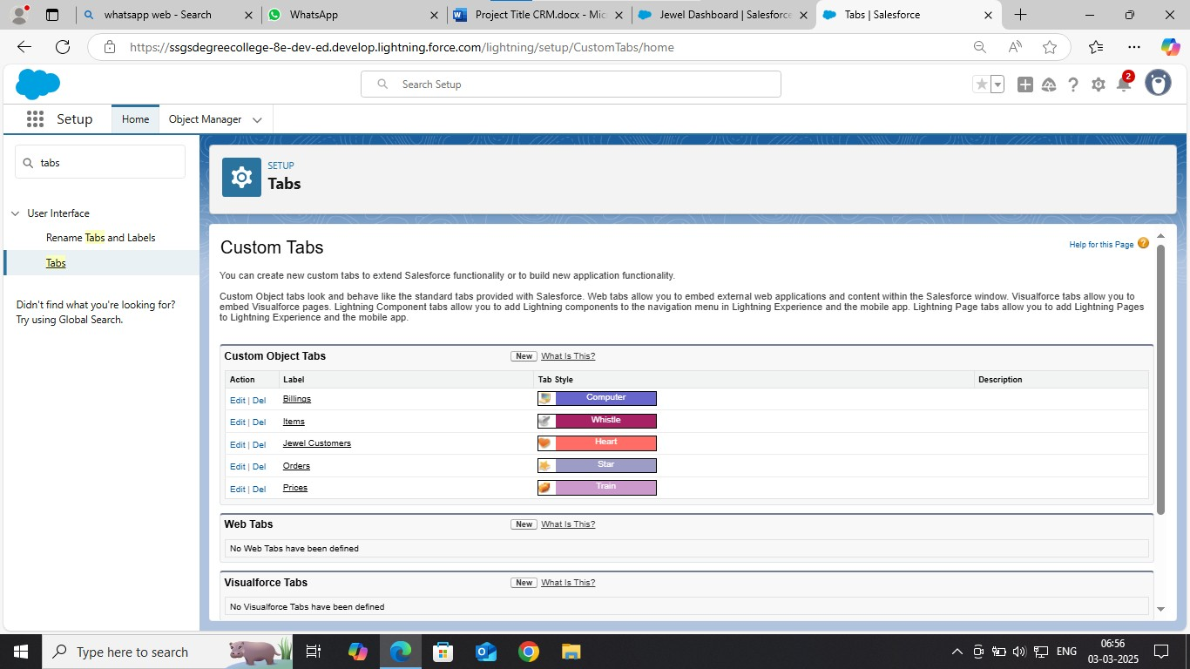

### Flows:-

***We* created flows**

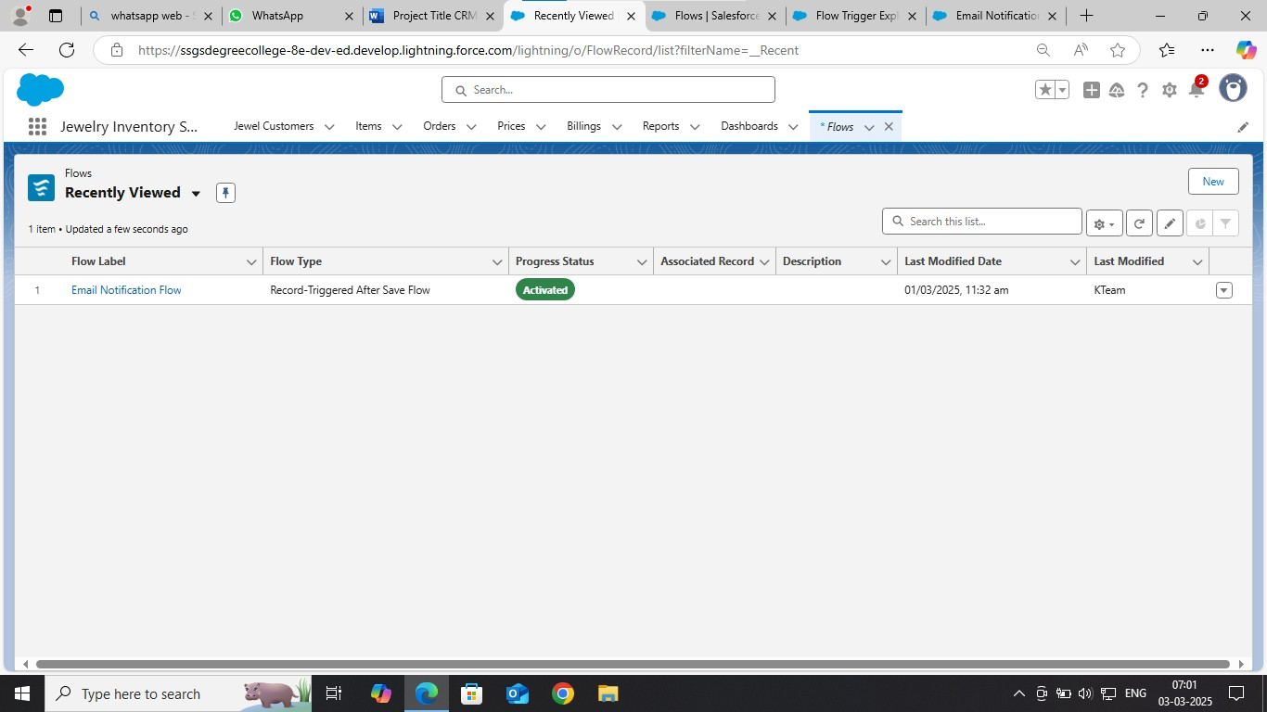

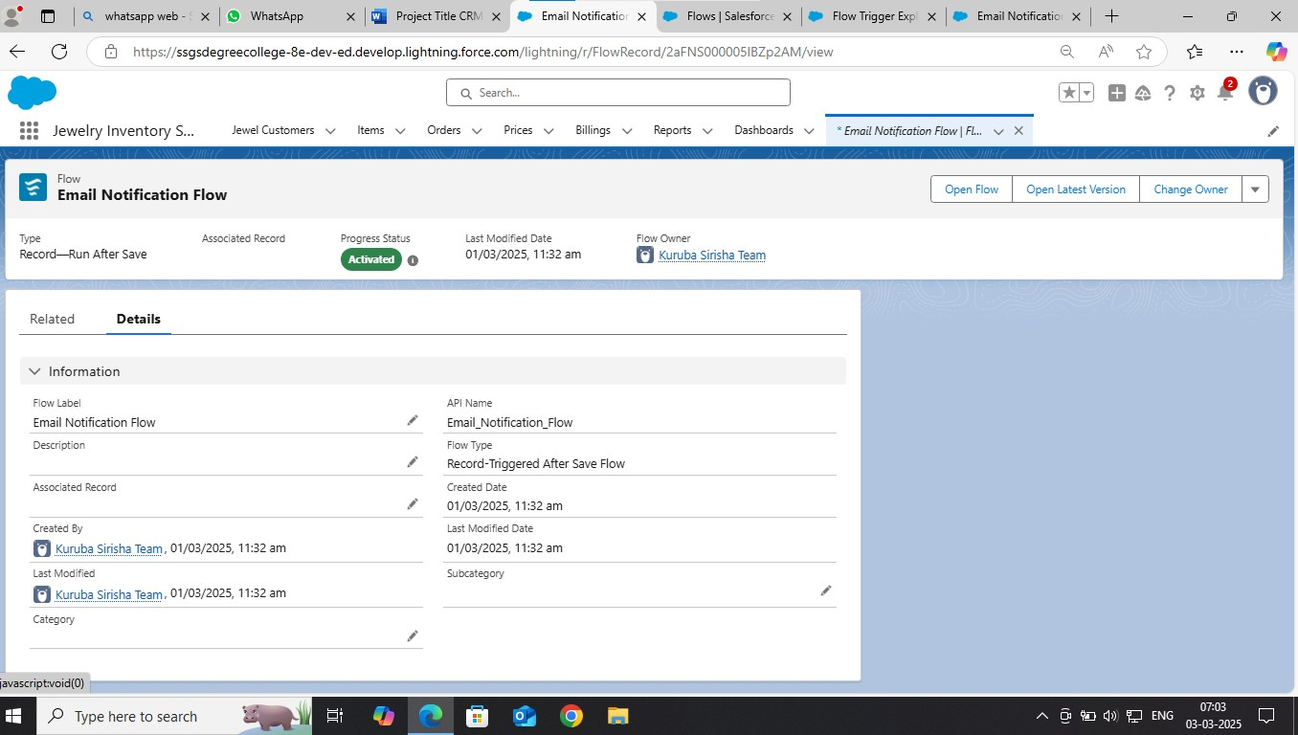

***(5) Testing & Validation:***

***User Interface Testing:***

❖ ***Record Types:-***

**We Created Record types in item object and labeled as “Gold" and “Silver”.**

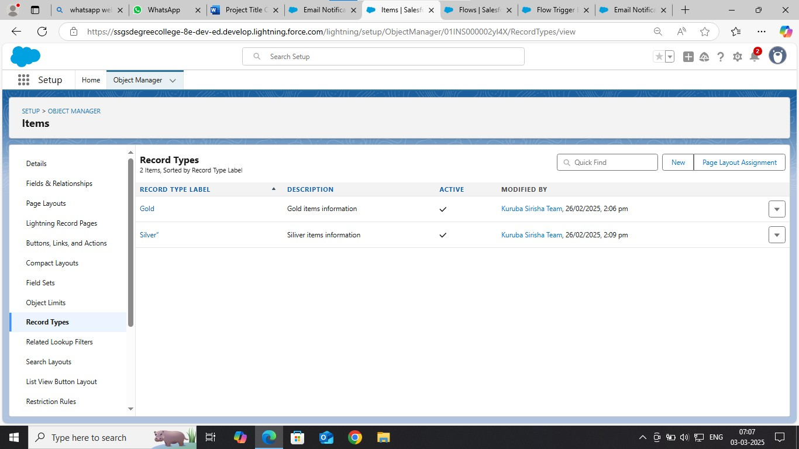

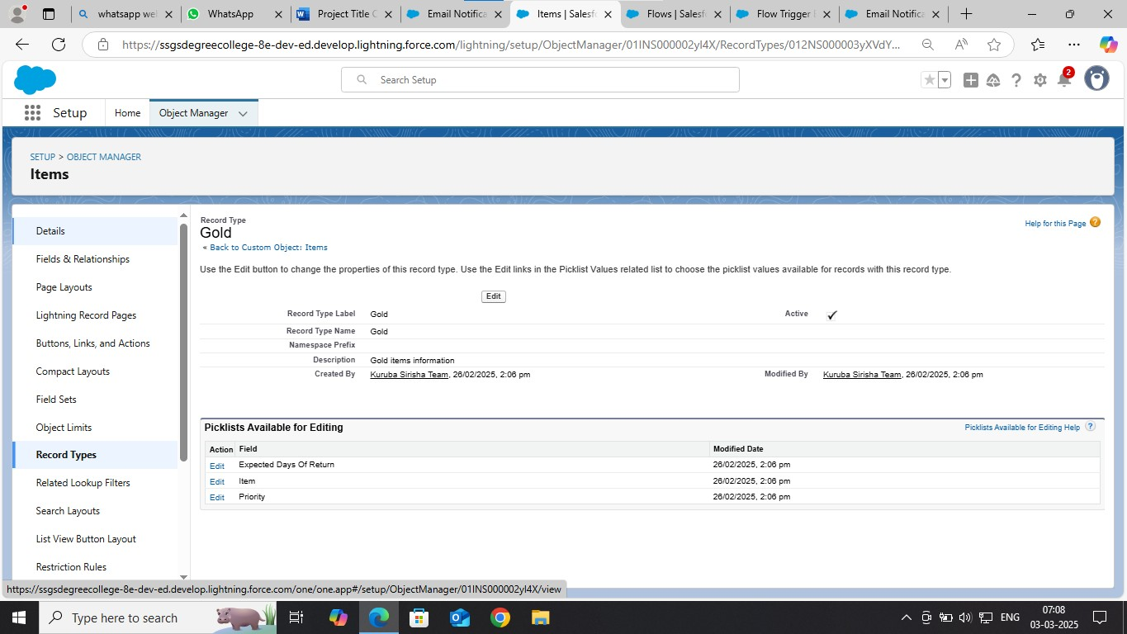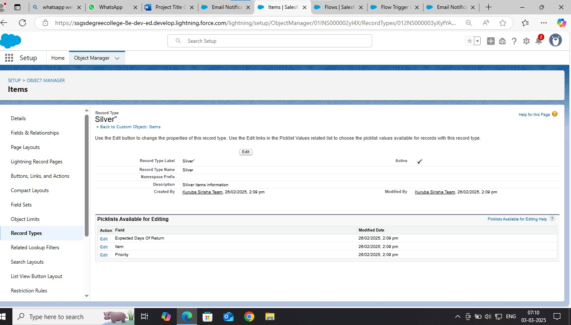

####  Permission Sets: -

**We created permission sets and labeled as “Per to Worker “and selected object permissions for “Read, Edit, Create”.**



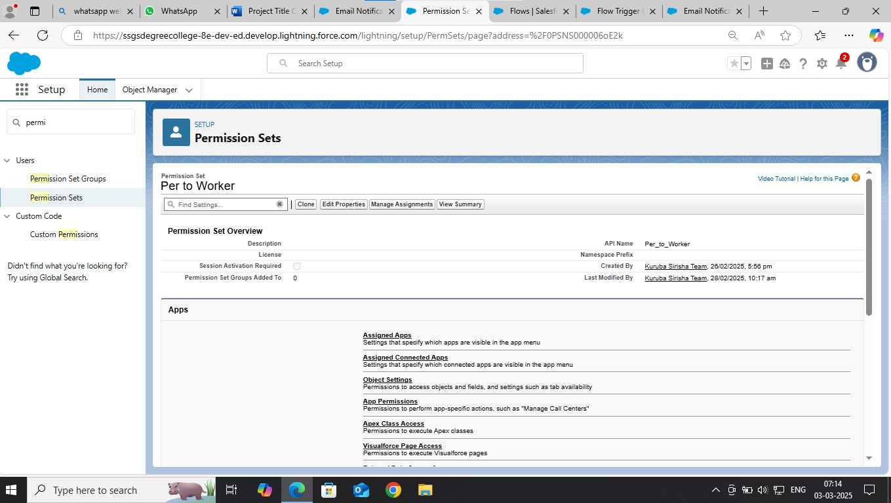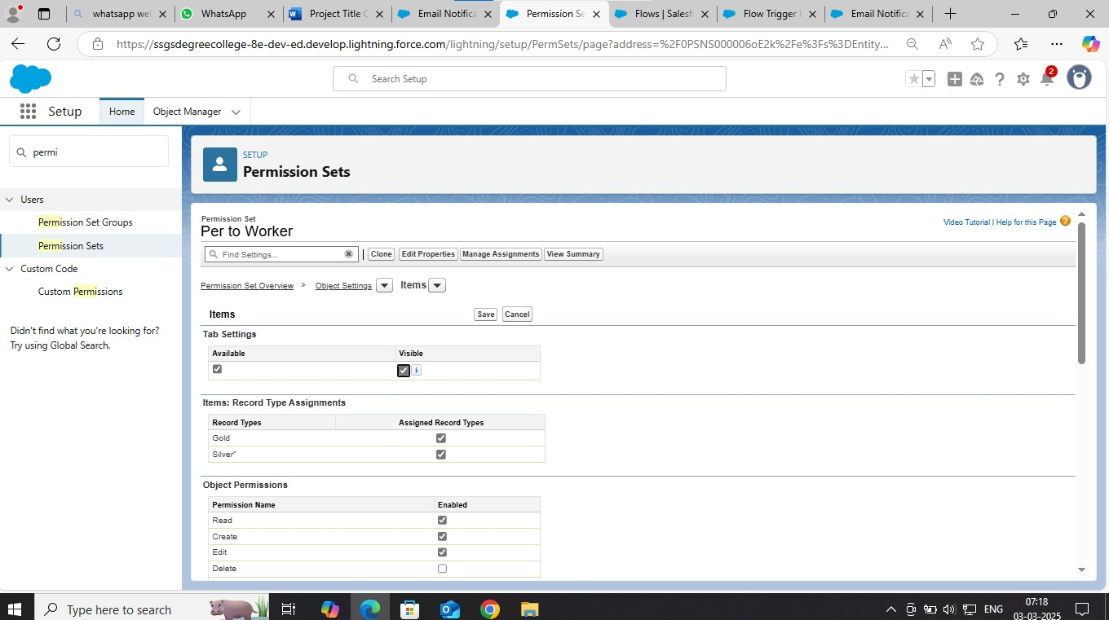

####  Profiles: -

**We created 2 Profiles and given name as**

* **Gold Smith Profile**
* **Worker Profile**

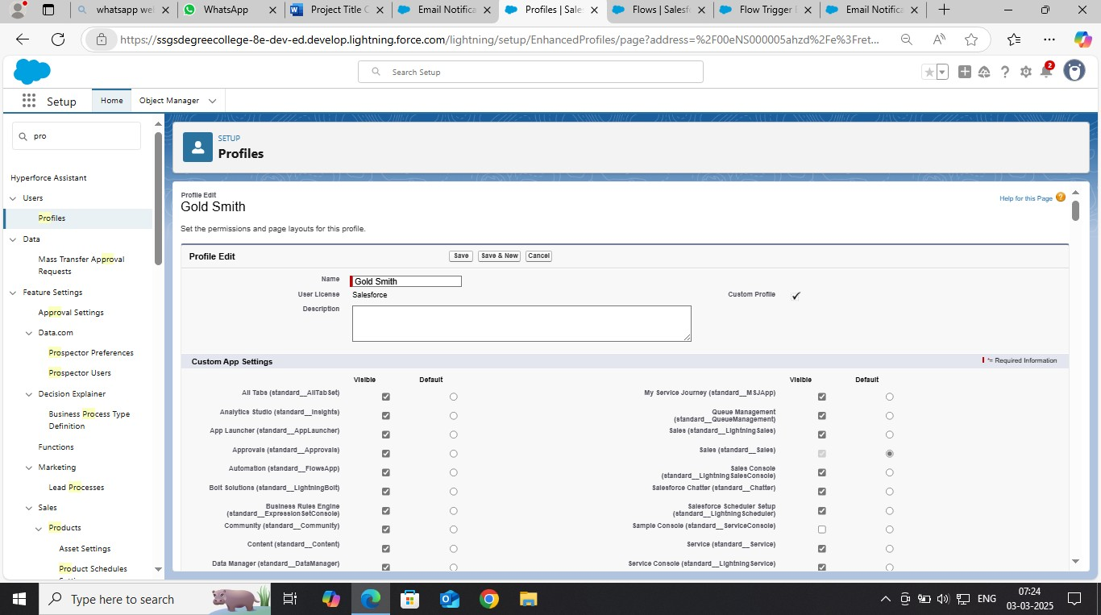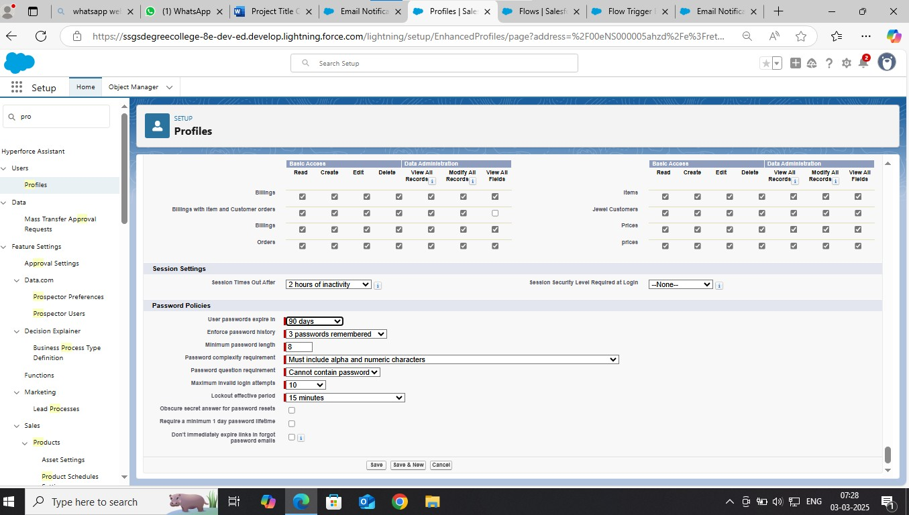

★

####  Validation Rules: -

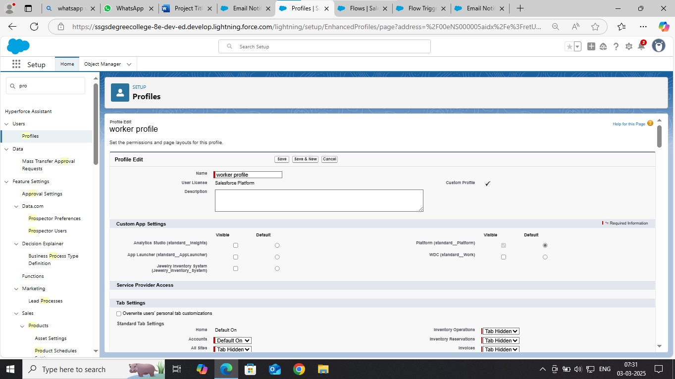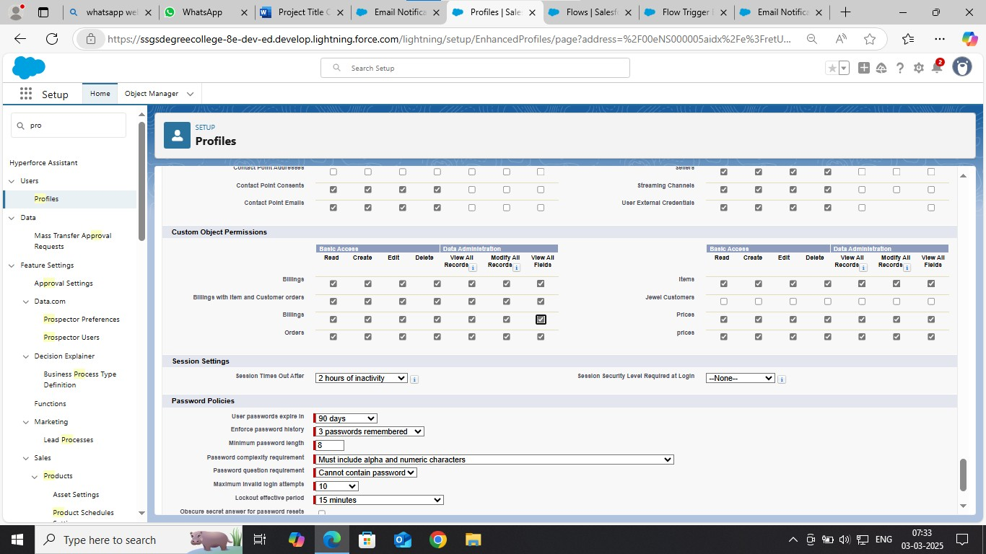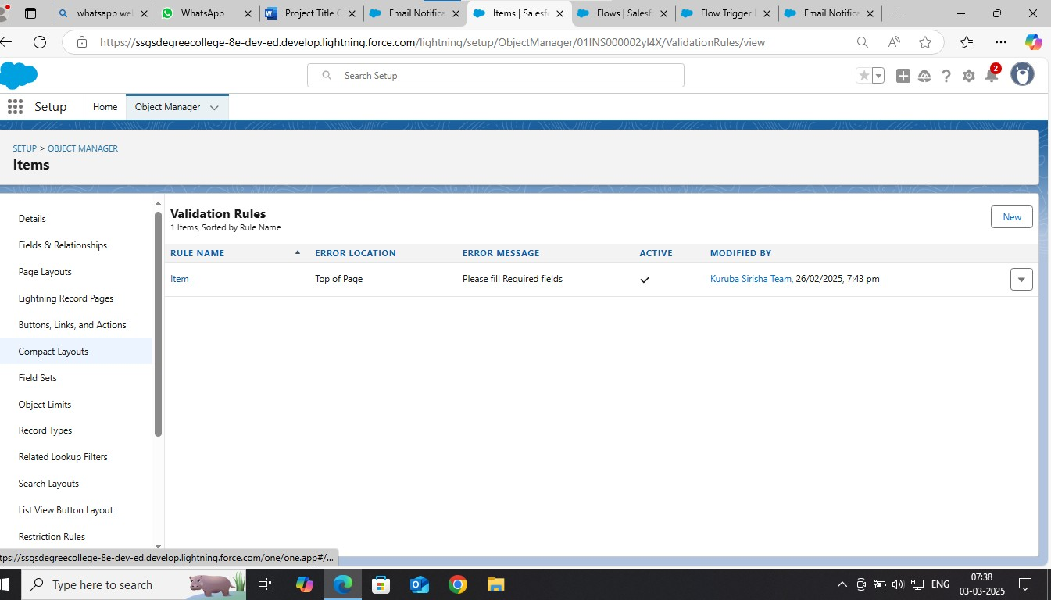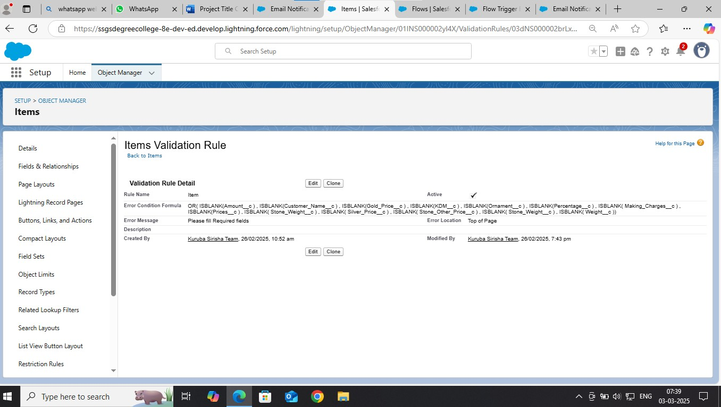

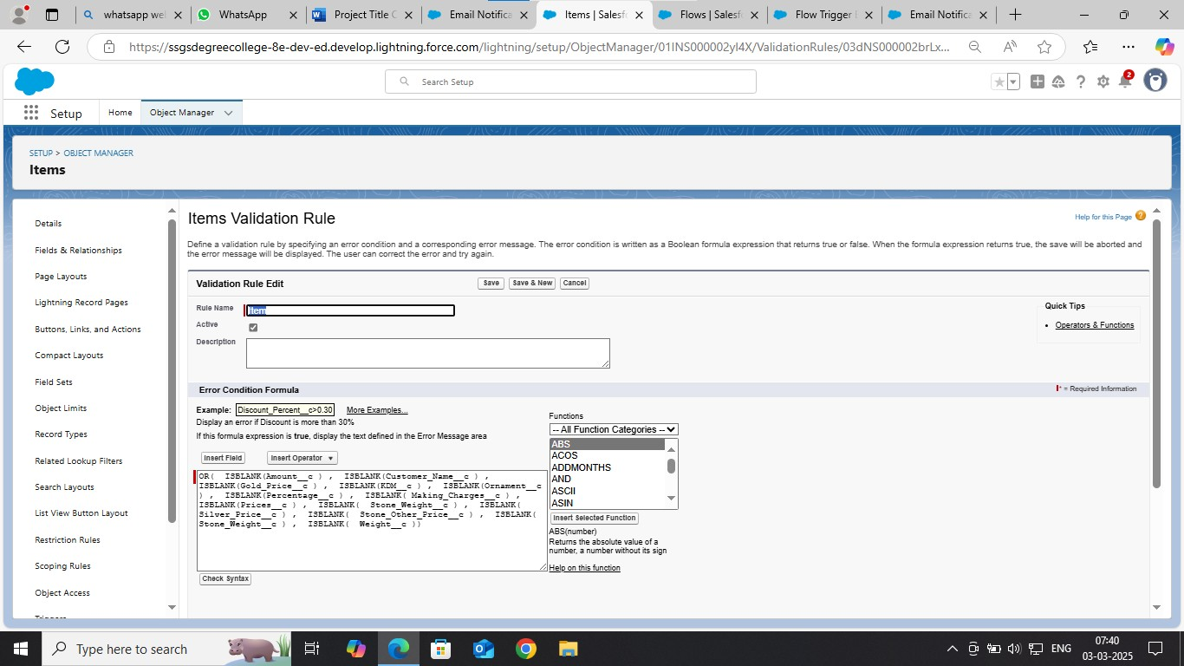

####  Flows: -

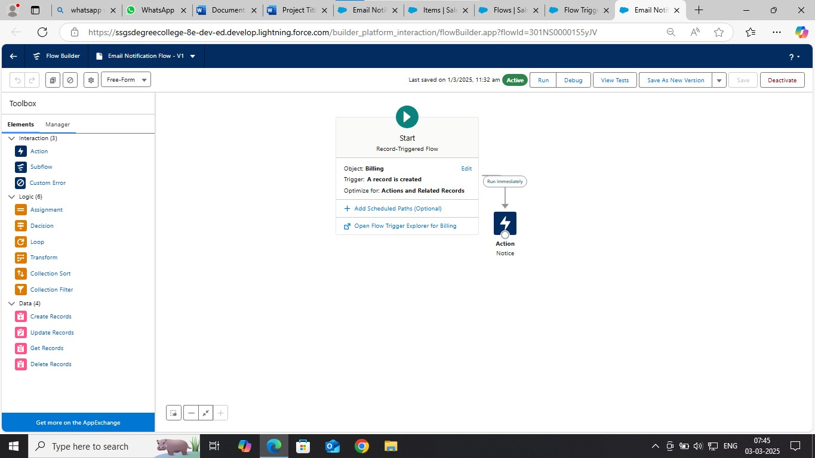

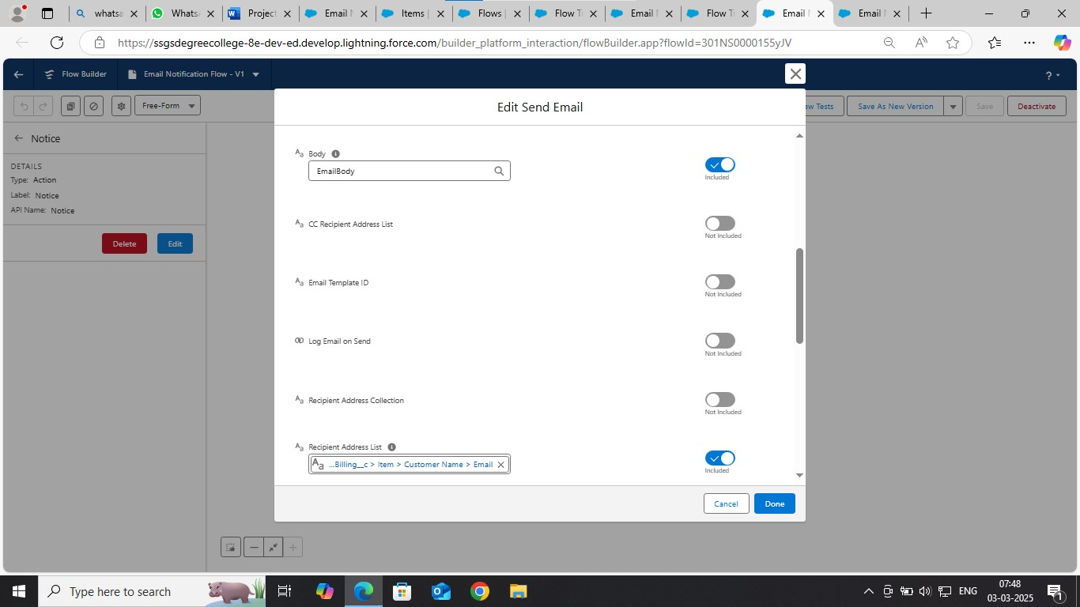

### User Adoption: -

We created some jewel customers, items, billings, prices,customer orders in **Jewelry Inventory System.**

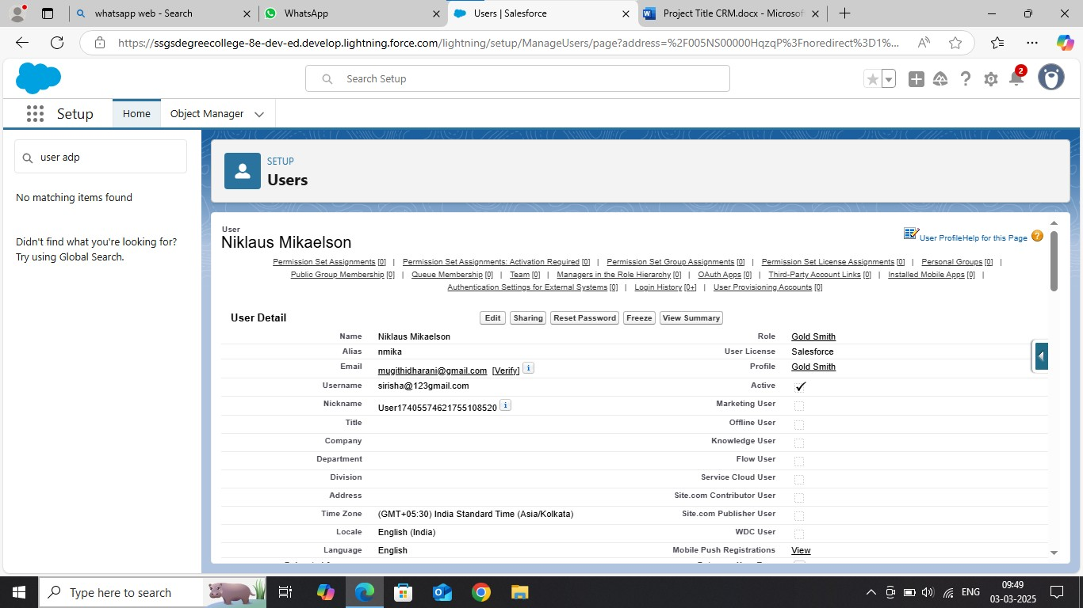

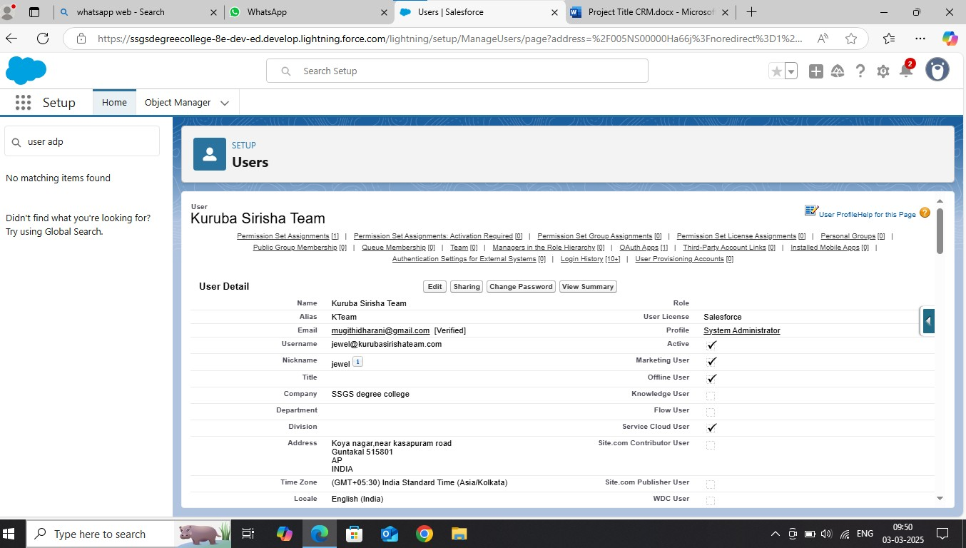

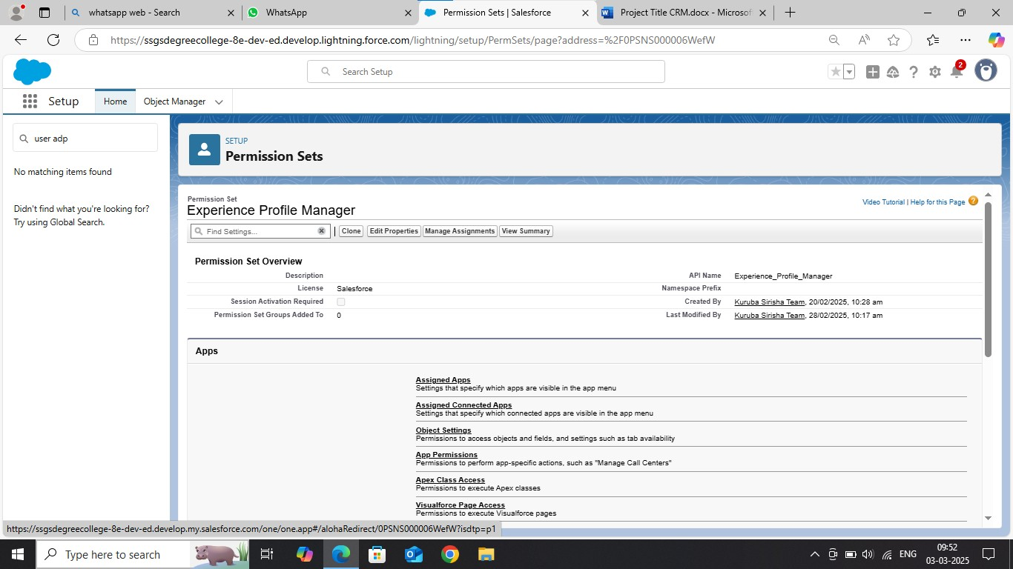

**(6) Conclusion: -**

CRM is a tool that allows businesses to manage relationships with their

customers effectively. Customer Relationship management is a business strategy that enables a business organization to maximize revenue, customer satisfaction, and profitability through strategic mobilization, organization, and management of customer’s interests and desires. BWM has traversed numerous business challenges that made it establish a CRM that will foster customer relationship as a baseline for market strengthening and diversification. BMW has diversified its market in various global markets through the initiation of the CRM systems. The system has significantly contributed to the company’s financial, operational, managerial and development initiatives with a robust customer relationship that has fostered great sales of its product. Mercedes Benz operates a similar customer relationship management system just BMW and due to market power, the company has its customerroots to various market bases. Mercedes has majored in customer-dealership business relationships. This has provided the company with strategic mechanization of customer retention, satisfaction and purchase behavior enhancing the company’s profitability through an increased purchase command. The two companies are among the leading CRM implementers in automotive.

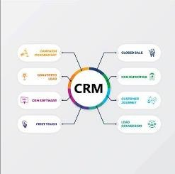

**CRM system is critical for jewelry businesses, allowing them to effectively manage customer relationships by centralizing data, enabling personalized interactions, optimizing sales processes, and gaining valuable insights into customer behavior, ultimately leading to increased sales, improved customer loyalty, and a more streamlined business operation through tailored marketing strategies and exceptional customer service.**

**A CRM (Customer Relationship Management) system for jewelers is essential for managing customer relationships, enhancing sales, and improving overall business efficiency.**

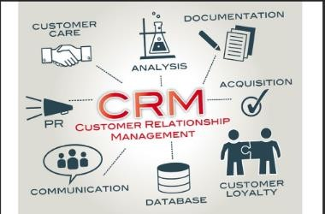

**Jewelry businesses face a multitude of challenges, from fierce competition to changing consumer preferences and limited budgets for marketing and advertising. It can be a tough market to navigate, but the good news is that implementing a customer relationship management (CRM) system can help overcome many of these challenges.**

**One of the biggest challenges facing jewelry businesses is the need to stay relevant and top of mind with customers. With so many options available, consumers are easily distracted and can quickly forget about your brand. A CRM system can help you stay top of mind by enabling you to communicate with customers on a regular basis and provide personalized recommendations based on their preferences.**

**Another challenge is managing inventory and ensuring that you have the right products available at the right time. A CRM system can help you keep track of inventory levels and alert you when products are running low or need to be restocked. This can help you avoid lost sales due to out-of-stock items and ensure that you always have a variety of products available to meet customer demand.**

**Finally, jewelry businesses face the challenge of attracting new**

**customers and retaining existing ones. A CRM system can help you identify customer segments and target them with personalized marketing messages that resonate with their specific interests and preferences.**